Assignment 2

Javaria Shabbir

21L-6053

BCS-7A

# Image Restoration

## Image # 1 Restoration

The image was loaded and converted to grayscale, then I applied color adjustment, Gaussian filtering, and sharpening. Finally, I smoothed the edges to enhance the image quality and displayed the restored result.

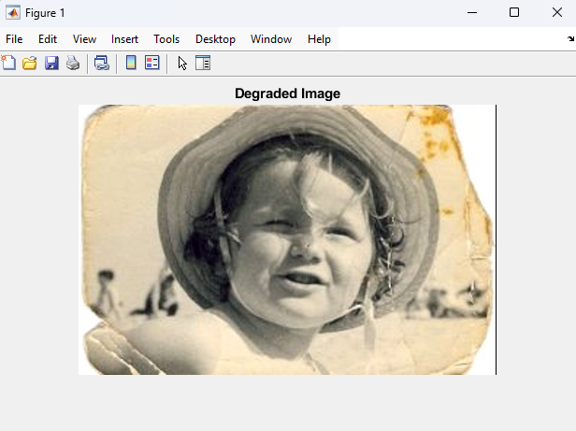

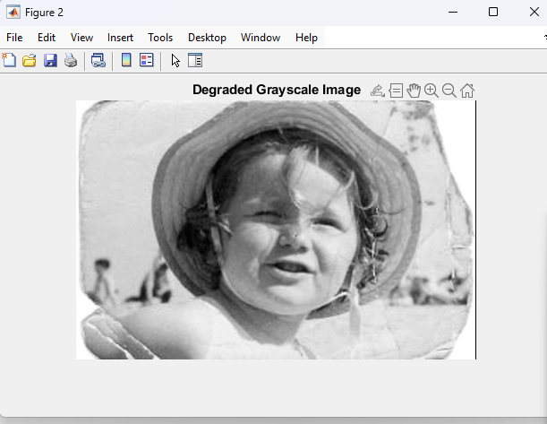

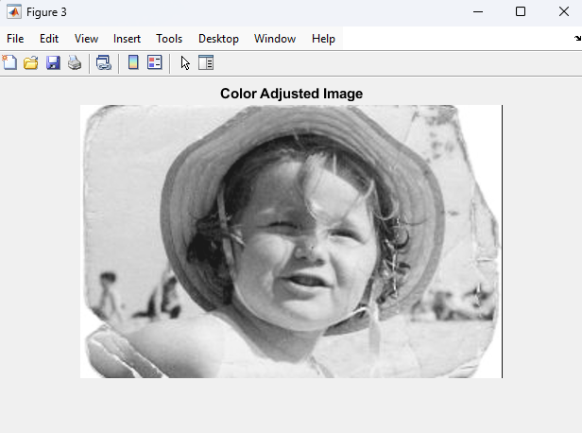

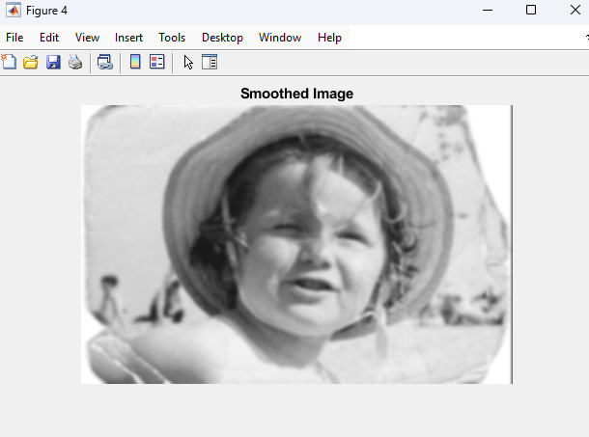

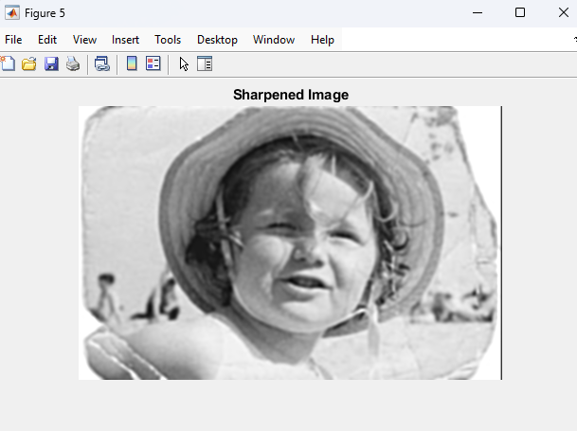

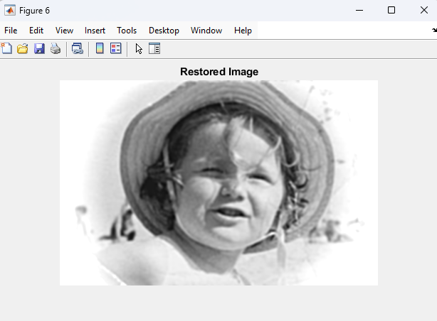

## Image # 2 Restoration

I loaded the image, converted it to grayscale, and removed the yellowish tint before normalizing it. The inpainting function was used to restore the missing or corrupted pixels, followed by displaying the result.

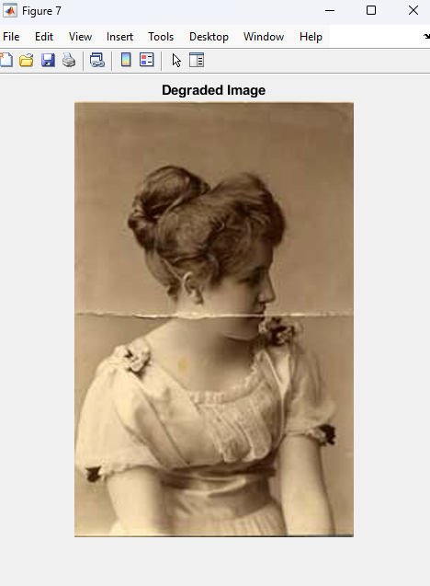

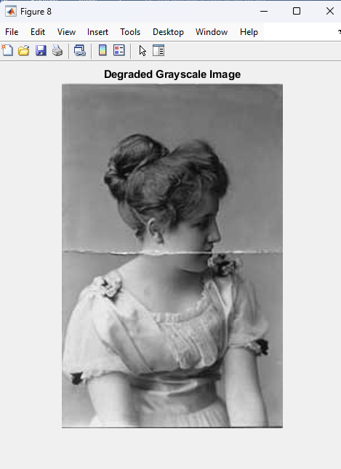

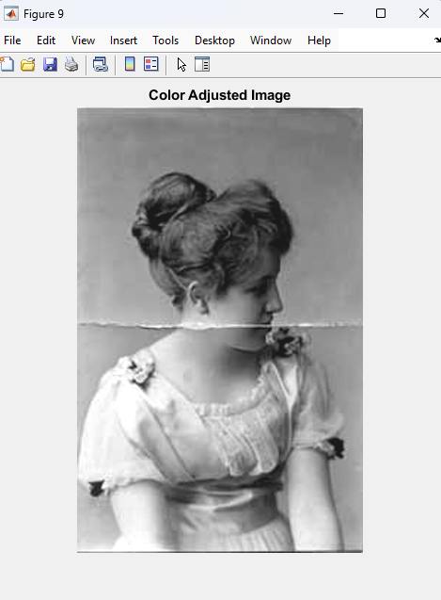

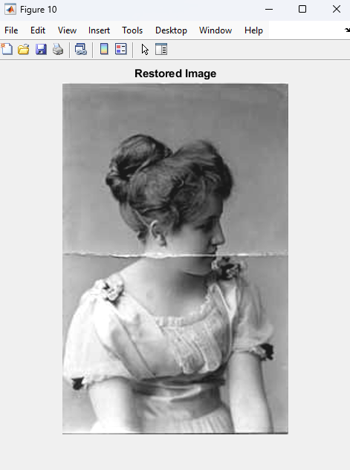

## Image # 3 Restoration

I loaded and converted the image to grayscale, then applied Gaussian filtering to reduce noise. The denoised image was displayed to show the improvement in clarity.

